GT Username: sanne31@gatech.edu
PART 1: GET FAMILIAR WITH R
R is a language which is used mostly for statistical computations and graphing various plots. It provides a large multitude of statistical techniques – linear and non-linear modeling techniques such as regression, time series analysis, classification, clustering, etc. – and graphical techniques.
R is also an interpreted language which has several noticeable advantages over the general compiled languages. Some basic differences are:
Considering Factor | Compiled Languages | Interpreted Languages
INPUT | Takes an entire program as its input | Takes a single line of code/instruction as its input
OUTPUT | Generates immediate object code | Doesn’t generate any immediate object code
SPEED | Executes faster | Executes slower
MEMORY | Requires more memory in order to create object code | Requires less memory as it doesn’t create any object code
WORKLOAD | Doesn’t need to compile every single time -> only once | Has to convert high level languages to low level programs at the time of execution so inherently the workload is larger than that of compiled languages
ERRORS | Displays errors once the entire program is checked | Displays errors for each line of instruction

A simple example of using R for statistical and graphical analysis:
R code for Graphing Y = X²
x = 1:20
y = x*x
plot(y)

Plot
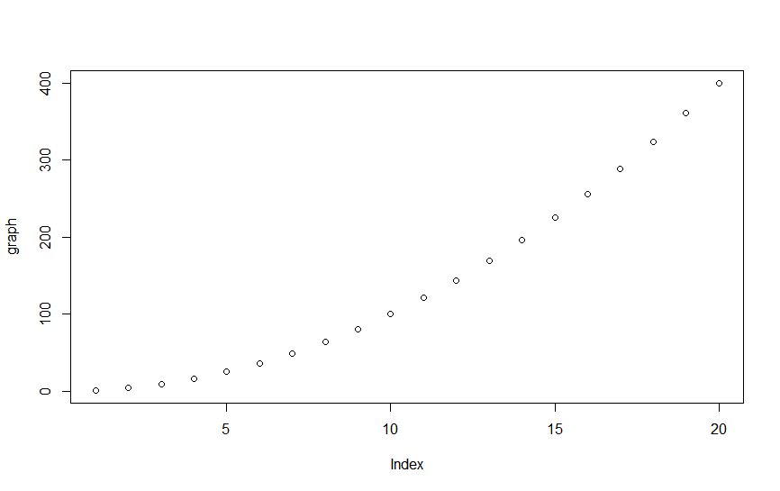
References: https://www.upwork.com/hiring/development/the-basics-of-compiled-languages-interpreted-languages-and-just-in-time-compilers/

PART 5: COMPARE RESULTS TO BUILT IN R FUNCTION

